**Spring REST using Spring Boot 3**

**2. spring-rest-handson**

**REST - Get country based on country code**

* **com.cognizant.spring_learn.controller**

**CountryController.java**

package com.cognizant.spring_learn.controller;

import com.cognizant.spring_learn.Country;

import com.cognizant.spring_learn.service.CountryService;

import org.springframework.beans.factory.annotation.Autowired;

import org.springframework.web.bind.annotation.*;

@RestController

public class CountryController {

@Autowired

private CountryService countryService;

@GetMapping("/countries/{code}")

public Country getCountry(@PathVariable String code) {

return countryService.getCountry(code);

}

}

* **com.cognizant.spring_learn.service**

**CountryService.java**

package com.cognizant.spring_learn.service;

import java.util.List;

import org.springframework.stereotype.Service;

import org.springframework.context.support.ClassPathXmlApplicationContext;

import com.cognizant.spring_learn.Country;

@Service

public class CountryService {

public Country getCountry(String code) {

try (ClassPathXmlApplicationContext context = new ClassPathXmlApplicationContext("country.xml")) {

List<Country> countryList = context.getBean("countryList", java.util.ArrayList.class);

return countryList.stream()

.filter(country -> country.getCode().equalsIgnoreCase(code))

.findFirst()

.orElse(null); // or throw custom NotFoundException

}

}

}

* **country.xml**

<?xml version="1.0" encoding="UTF-8"?>

<beans xmlns="http://www.springframework.org/schema/beans"

xmlns:xsi="http://www.w3.org/2001/XMLSchema-instance"

xsi:schemaLocation="http://www.springframework.org/schema/beans

http://www.springframework.org/schema/beans/spring-beans.xsd">

<bean id="country" class="com.cognizant.spring_learn.Country">

<property name="code" value="IN"/>

<property name="name" value="India"/>

</bean>

<bean id="countryList" class="java.util.ArrayList">

<constructor-arg>

<list>

<bean class="com.cognizant.spring_learn.Country">

<property name="code" value="IN"/>

<property name="name" value="India"/>

</bean>

<bean class="com.cognizant.spring_learn.Country">

<property name="code" value="US"/>

<property name="name" value="United States"/>

</bean>

<bean class="com.cognizant.spring_learn.Country">

<property name="code" value="CN"/>

<property name="name" value="China"/>

</bean>

</list>

</constructor-arg>

</bean>

</beans

* **Country.java**

package com.cognizant.spring_learn;

public class Country {

private String code;

private String name;

public String getCode() { return code; }

public void setCode(String code) { this.code = code; }

public String getName() { return name; }

public void setName(String name) { this.name = name; }

@Override

public String toString() {

return "Country [code=" + code + ", name=" + name + "]";

}

}

➤ URL:

<http://localhost:8083/countries/in>

* **OUTPUT:**

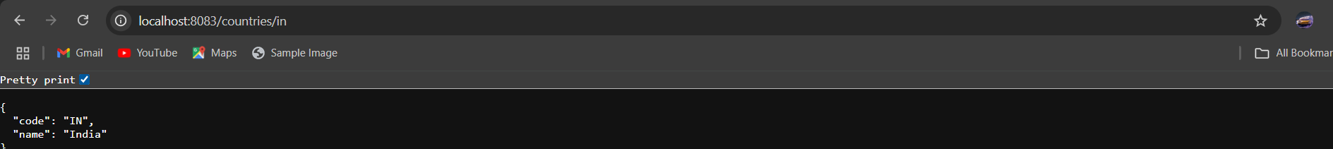

* **URL:**

<http://localhost:8083/countries/us>

* **OUTPUT:**



* **URL:**

<http://localhost:8083/countries/cn>

